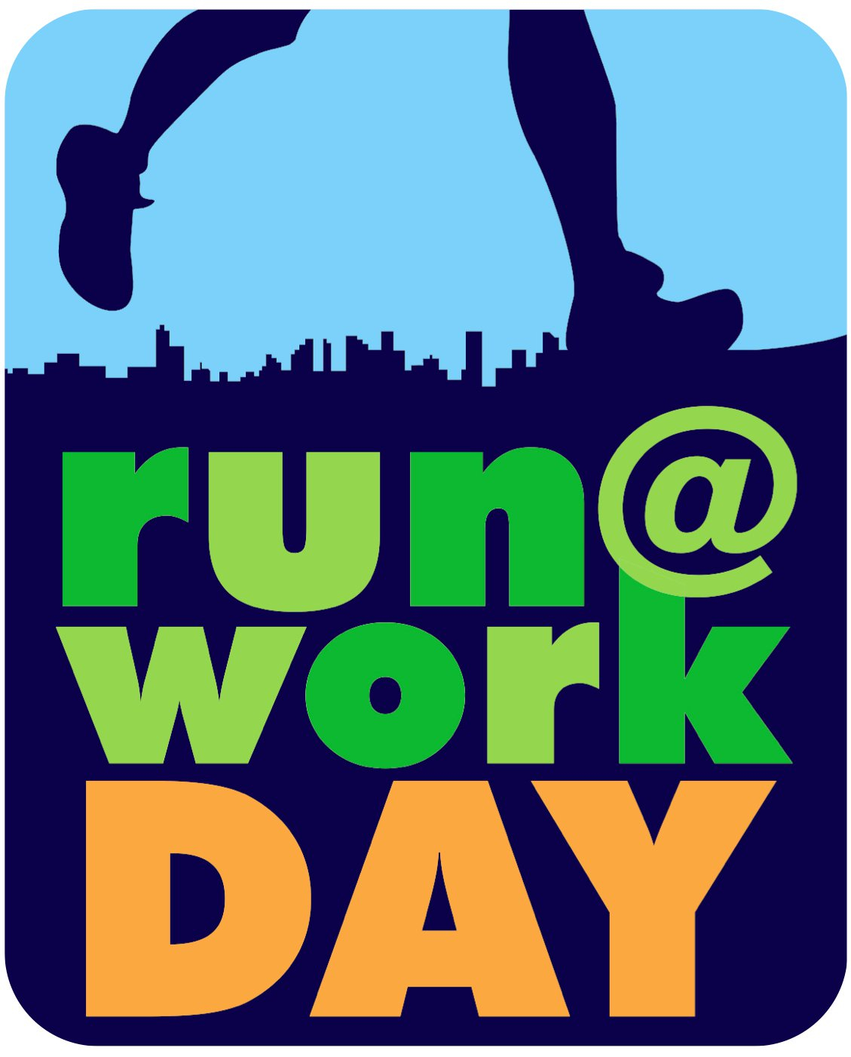
Mayor Kimberley Driscoll
Salem Park, Recreation & Community Services and the Wicked Running Club
present:
1st Annual Salem Run@Work Day

What: The goal of Run@Work Day is to raise awareness about the importance of daily physical activity for adults. National Run@Work Day events are community based events that promote and provide the opportunity for individuals to incorporate at least 30-minutes of exercise, in accordance with the National Physical Activity Guidelines, into their daily routine either before work, during lunch, or immediately following work. Incorporating exercise into one’s daily routine can markedly improve one’s overall physical health.
When: Friday, September 16, 2011 12:00PM

Where: Salem Common

Why: Great opportunity to network with runners and promote products, retail or service business, or running club.

For event details contact Tim Short: tim.short1@gmail.com

Go to http://wickedrunningclub.com/salem-run-at-workday for event information.

^{1st} Annual Salem Run@Work Day
Sponsorship Donation Agreement
We are asking local businesses if they would be interested in being a sponsor for the event. Sponsorships will enable us to provide T shirts and refreshments for runners. Businesses that make sponsorship in the amount of $50 or more will have their logo on the back of the shirt and be listed in all media announcements.
The event will be held at the Salem Common, Salem, Massachusetts 01970. Please return this form with your sponsorship donation to: Tim Short, 12 North Park Ave, Middleton, MA 01949.
Email business logos to tim.short1@gmail.com, Deadline to make T shirts, August 20, 2011 Thank you for supporting the Salem running community!
---------------------------------------------------------------------------------------------
SPONSORSHIP AMOUNT:
____$50 Other:___________
Business Name

Contact Name:______________________________________________________

Address:______________________________________City_________________

Phone:______________________________email:_________________________

